Network Switching 2015 Case Study (group assignment)

|  |
| --- |
| **Contents**   [[hide](http://intsec-wiki.murdoch.edu.au/wiki/index.php/Network_Switching_2015_Case_Study_%28group_assignment%29)]   * [1 Resources](http://intsec-wiki.murdoch.edu.au/wiki/index.php/Network_Switching_2015_Case_Study_%28group_assignment%29#Resources) * [2 Group Structure](http://intsec-wiki.murdoch.edu.au/wiki/index.php/Network_Switching_2015_Case_Study_%28group_assignment%29#Group_Structure) * [3 Scenario](http://intsec-wiki.murdoch.edu.au/wiki/index.php/Network_Switching_2015_Case_Study_%28group_assignment%29#Scenario) * [4 VLANs](http://intsec-wiki.murdoch.edu.au/wiki/index.php/Network_Switching_2015_Case_Study_%28group_assignment%29#VLANs) * [5 IP Addressing Requirements](http://intsec-wiki.murdoch.edu.au/wiki/index.php/Network_Switching_2015_Case_Study_%28group_assignment%29#IP_Addressing_Requirements) * [6 Routing Requirements](http://intsec-wiki.murdoch.edu.au/wiki/index.php/Network_Switching_2015_Case_Study_%28group_assignment%29#Routing_Requirements) * [7 Optimisation](http://intsec-wiki.murdoch.edu.au/wiki/index.php/Network_Switching_2015_Case_Study_%28group_assignment%29#Optimisation) * [8 Edge Devices](http://intsec-wiki.murdoch.edu.au/wiki/index.php/Network_Switching_2015_Case_Study_%28group_assignment%29#Edge_Devices)   + [8.1 Access Layer](http://intsec-wiki.murdoch.edu.au/wiki/index.php/Network_Switching_2015_Case_Study_%28group_assignment%29#Access_Layer) * [9 Deliverables](http://intsec-wiki.murdoch.edu.au/wiki/index.php/Network_Switching_2015_Case_Study_%28group_assignment%29#Deliverables) * [10 Errata and Changes](http://intsec-wiki.murdoch.edu.au/wiki/index.php/Network_Switching_2015_Case_Study_%28group_assignment%29#Errata_and_Changes) |

Resources

You can download the required Packet Tracer version 6.2 software from this link.

[Packet Tracer 6.2 for Windows Download](http://intsec-wiki.murdoch.edu.au/wiki/images/2/2e/Cisco_Packet_Tracer_6.2_for_Windows_%28no_tutorials%29.exe)

[Packet Tracer 6.2 for Linux Download](http://intsec-wiki.murdoch.edu.au/wiki/images/6/6d/Cisco_Packet_Tracer_6.2_for_Linux_-_Ubuntu_installation_-_Student_version_no_tutorial.tar.gz)

Group Structure

Students should self select themselves into a group see LMS for details.

[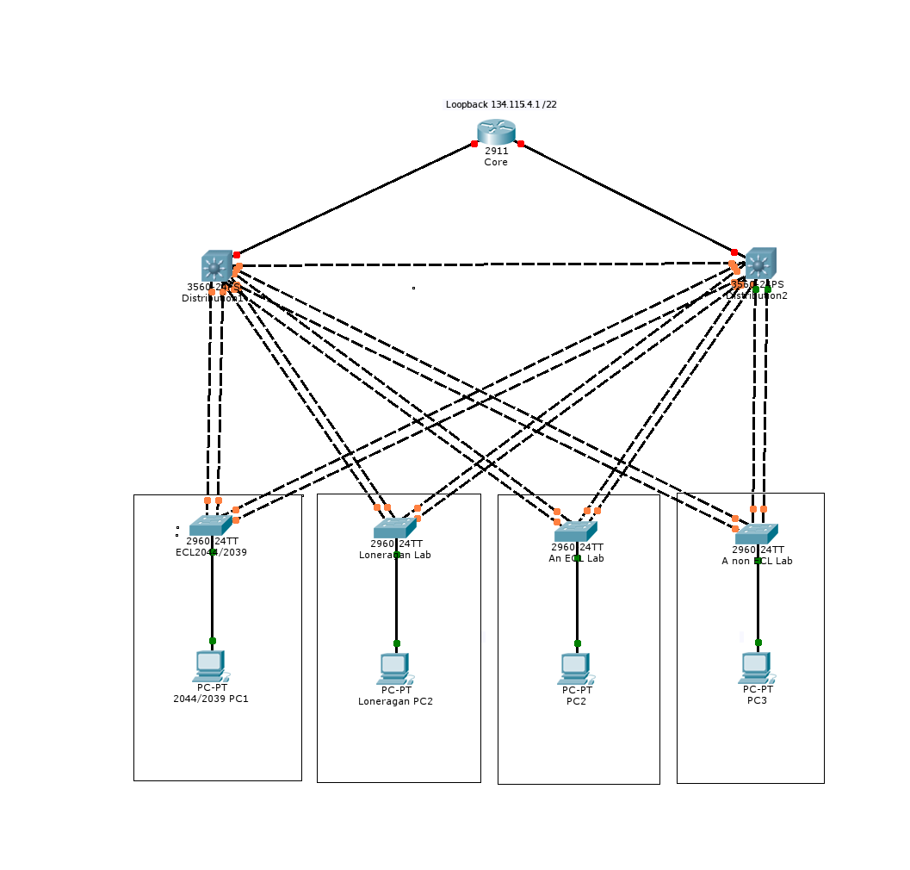](http://intsec-wiki.murdoch.edu.au/wiki/index.php/File:2015-Network-Switching-Case-Study-Topology.png)

Scenario

You have been tasked with modelling a part of the Murdoch University Computer Lab network using Packet Tracer. This assignment requires you to model five laboratories. Three of these laboratories are mandatory (ECL2.044 and ECL2.039 and Loneragan labs). The other two laboratories are of your own choosing. However, one must be from within the ECL building (It's changed names now but it is the building containing the 2039/2044 labs) and one must be from elsewhere on campus.

**It is essential that you use Packet Tracer Version 6 to complete this assignment.**

[Packet Tracer Topology File](http://intsec-wiki.murdoch.edu.au/wiki/images/a/ad/Network-Switching-Assignment-2015-PT-Topology-v1.00.pkt)

VLANs

* You should create and name VLANs to model the structure seen in the labs. You do not need to determine the actual VLAN numbers used in the lab. Merely model the structure.
* You should create a management VLAN and ensure that any PC on the network can telnet into any of the switches or routers in order to allow remote management.

IP Addressing Requirements

You should visit each of the laboratories that you have selected and determine the IP addressing range used in each environment. With this information you should be able to infer a VLAN structure (End-to-end, local or mixed). It is this VLAN structure and the IP addressing that you need to model. Note that no other elements of the real Murdoch implementation need to be implemented or modelled. The actual design and implementation of the Packet Tracer network is governed by the topology given and the requirements and constraints listed below. In particular there is no requirement to perform any "traceroute" on the Murdoch network to determine the network structure and the routing arrangements.

* The modelled labs should use the same IP subnet as their real counterparts.
* The subnet sizes should accommodate the number of hosts required for your labs. Note that you do not need to add extra switches to provide for more than 24 ports. The physical layer in your model is merely to facilitate testing of your logical design.
* The default gateway for each lab should model the configuration you find in the labs.
* A loopback address of 134.115.4.1 /22 needs to be included on the Core Router. This is for testing purposes and you need to configure your routing to allow it to be "pinged".
* Any additional IP addresses that are required for links between devices should be taken from the address space in 134.115.0.0/24. Point to point links should use a /30 prefix.
* A single DHCP server should be implemented for each of the lab VLANs present. No redundancy is required.
* It should be possible to add new hosts to the lab access layer switches and have them self configure enabling them to participate in the network.

Routing Requirements

You must provide interVLAN routing, such that all devices can ping one another.

* OSPF should be used as the routing protocol.
* InterVLAN routing should be included for each VLAN that carries data or management traffic.
* The core/distribution region of the network should be routed.
* The distribution/access region of the network should be switched.
* It is possible to adopt a routed or switched approach for the link between the two DL switches. You can adopt either but you must justify your approach.

Optimisation

Wherever possible, within the limitations of Packet Tracer Version 6, you should:

* Maximise the redundancy of links and devices through configuration. Note however that the topology cannot be altered from that provided. You are also not permitted to add any additional routers or switches to the topology. (FHRP)
* Ensure sensible and efficient traffic paths. In particular you should pay attention to the STP topology and the allocation of gateway addresses. (root bridge and dhcp server alignment)
* Ensure full use of the available bandwidth, link and router capacity through the use of redundant links and devices. Note that the use of the load-balancing features of some routing protocols is outside the scope of this assignment. (etherchannel,fhrp load balancing)
* Take into account the convergence, or recovery, time after a device failure and select protocols and techniques that minimise the time taken to recover. Note there is no need to alter any default timers. Merely to choose sensibly among the available protocols and techniques. (rapid pvst)
* Take steps to protect your topology and protocols from malicious devices that can mascarade as a switch or router through the creation of custom protocol packets. (nonnegotiate)

Although there are constraints imposed by Packet Tracer version 6, the design, technology and techniques used are left to your professional judgement. You should examine each of the technologies and techniques explored in ICT363. Where relevant (and appropriate) to the scenario you should include the technology in your design. Don't include a technology if it is not justifiable in the context of a lab network.

In the absence of specific requirements you should use best practices with a view to creating a design that performs well, is fault tolerant(fhrp), scalable(vtp) and maintainable(root bridge). Where there is a choice between a proprietary technology and a standards based approach, the standards based approach should be adopted unless there is a compelling performance or functional reason for choosing the proprietary approach.

Edge Devices

**Access Layer**

A single PC is provided in each lab for testing. You may add more if necessary. You should also configure the access layer switches to ensure the following:

* When a PC is powered up it should have immediate connectivity to the network.(portfast/edge port)
* Lab users are not permitted to connect additional switches to the network. You should discourage users from trying this by shutting down the port when BPDU's are detected on an edge port.

Deliverables

On or before the due date you should submit the following using the Assignment Submission tool in LMS:

* List the names and student numbers of each of the group members.
* Submit a written report which includes:
  + A list of the labs you have included in your model.
  + An explanation of the VLAN structure and IP addressing scheme used.
  + An outline of the design and a brief justification for any design decisions.
  + The report should be in PDF format. (Bullzip for Windows and cups-pdf for Ubuntu are free and effective).
* Packet Tracer implementation of your network.

Treat the report as an item of documentation for future reference and as an aid to troubleshooting. Assume your audience has a similar technical understanding to that of yourself or your peers. In justifying your choices you do not need to explain to the reader how a particular technique or protocol works. You merely need to highlight the features or characteristics that led you to conclude that your implementation was the best approach. It is important to structure the document well and keep it as brief as possible so that pertinent information doesn't become buried in unnecessary material.

Errata and Changes

* Should any changes and corrections be made to this page, the changes will be summarised here.

Navigation menu

* [Ccnp-student](http://intsec-wiki.murdoch.edu.au/wiki/index.php/User:Ccnp-student)
* [Talk](http://intsec-wiki.murdoch.edu.au/wiki/index.php/User_talk:Ccnp-student)
* [Preferences](http://intsec-wiki.murdoch.edu.au/wiki/index.php/Special:Preferences)
* [Watchlist](http://intsec-wiki.murdoch.edu.au/wiki/index.php/Special:Watchlist)
* [Contributions](http://intsec-wiki.murdoch.edu.au/wiki/index.php/Special:Contributions/Ccnp-student)
* [Log out](http://intsec-wiki.murdoch.edu.au/wiki/index.php?title=Special:UserLogout&returnto=Network+Switching+2015+Case+Study+%28group+assignment%29)
* [Page](http://intsec-wiki.murdoch.edu.au/wiki/index.php/Network_Switching_2015_Case_Study_(group_assignment))
* [Discussion](http://intsec-wiki.murdoch.edu.au/wiki/index.php?title=Talk:Network_Switching_2015_Case_Study_(group_assignment)&action=edit&redlink=1)
* [Read](http://intsec-wiki.murdoch.edu.au/wiki/index.php/Network_Switching_2015_Case_Study_(group_assignment))
* [View source](http://intsec-wiki.murdoch.edu.au/wiki/index.php?title=Network_Switching_2015_Case_Study_(group_assignment)&action=edit)
* [View history](http://intsec-wiki.murdoch.edu.au/wiki/index.php?title=Network_Switching_2015_Case_Study_(group_assignment)&action=history)

Top of Form



Bottom of Form

Navigation

* [Main page](http://intsec-wiki.murdoch.edu.au/wiki/index.php/Main_Page)
* [Community portal](http://intsec-wiki.murdoch.edu.au/wiki/index.php/Murdoch_University_-_Internetworking_and_Security_Wiki:Community_portal)
* [Current events](http://intsec-wiki.murdoch.edu.au/wiki/index.php/Murdoch_University_-_Internetworking_and_Security_Wiki:Current_events)
* [Recent changes](http://intsec-wiki.murdoch.edu.au/wiki/index.php/Special:RecentChanges)
* [Random page](http://intsec-wiki.murdoch.edu.au/wiki/index.php/Special:Random)
* [Help](http://intsec-wiki.murdoch.edu.au/wiki/index.php/Help:Contents)

Toolbox

* [What links here](http://intsec-wiki.murdoch.edu.au/wiki/index.php/Special:WhatLinksHere/Network_Switching_2015_Case_Study_(group_assignment))
* [Related changes](http://intsec-wiki.murdoch.edu.au/wiki/index.php/Special:RecentChangesLinked/Network_Switching_2015_Case_Study_(group_assignment))
* [Special pages](http://intsec-wiki.murdoch.edu.au/wiki/index.php/Special:SpecialPages)
* [Printable version](http://intsec-wiki.murdoch.edu.au/wiki/index.php?title=Network_Switching_2015_Case_Study_(group_assignment)&printable=yes)
* [Permanent link](http://intsec-wiki.murdoch.edu.au/wiki/index.php?title=Network_Switching_2015_Case_Study_(group_assignment)&oldid=2121)
* [Page information](http://intsec-wiki.murdoch.edu.au/wiki/index.php?title=Network_Switching_2015_Case_Study_(group_assignment)&action=info)
* This page was last modified on 29 April 2015, at 09:08.
* This page has been accessed 21 times.
* [Privacy policy](http://intsec-wiki.murdoch.edu.au/wiki/index.php/Murdoch_University_-_Internetworking_and_Security_Wiki:Privacy_policy)
* [About Murdoch University - Internetworking and Security Wiki](http://intsec-wiki.murdoch.edu.au/wiki/index.php/Murdoch_University_-_Internetworking_and_Security_Wiki:About)
* [Disclaimers](http://intsec-wiki.murdoch.edu.au/wiki/index.php/Murdoch_University_-_Internetworking_and_Security_Wiki:General_disclaimer)
* [Powered by MediaWiki](http://www.mediawiki.org/)